
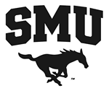
Law School on Your Mind?
All Panelists are
SMU Alumni!

