ELECTRICAL ENGINEERING DEPARTMENT
SOUTHERN METHODIST UNIVERSITY
FIBER OPTIC TELECOMMUNICATIONS
SMU EE 5303 NTU TM-513-N Midterm #1 February 26, 1996

Name (print): ________________________
Location: ________________________
Note #1: each question is worth 5 points.
Note #2: Some of the multiple choice questions may have more than one correct answer listed. If so, circle all of the correct responses for the question.
Note #3: Please print your name at the bottom of the remaining pages.
Note #4: Please indicate your location: NTU, TAGER, Video, Video on Campus, or Campus-live
Note #5: please provide a brief explanation of your answers to multiple-choice type questions.

1. i) What is the frequency of an optical wave that has a free space wavelength of λ = 1.6 µm?

ii) What is the energy of the photons in this optical wave?

iii) How many photons/sec with a wavelength of 1.6 µm are required to produce 1 mW of optical power?

2. When an electromagnetic wave propagates from one medium with an index of refraction of n1 = 3.5 into a second medium with an index of refraction of n2 = 1.5,
a) only the frequency changes,
b) only the wavelength changes,
c) both the frequency and the wavelength change, and/or
d) the frequency and the wavelength both remain the same.
Briefly explain your answer:

3. i) A fiber has an optical loss of 0.4 dB/km. What is the optical loss of an 800 km length of this fiber in units of dBs?

ii) Is the power out the end of the fiber (in part i)
a) equal to the input power,
b) greater than the input power, and/or
c) less than the input power.
Briefly explain your answer to part ii):

4. The figure below shows rays incident on the left-hand-side of the lens. Show the continuation of the rays on the right-hand-side of the lens.
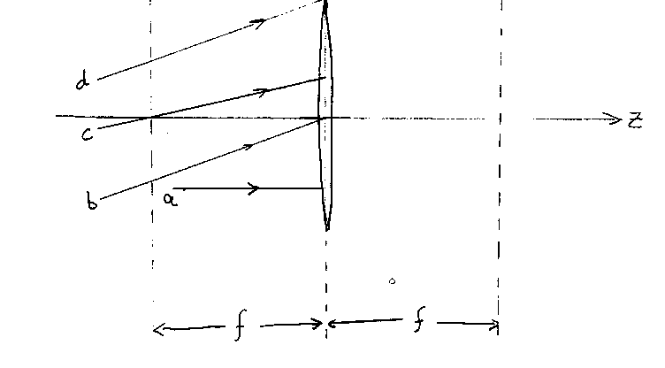

5. i) A light ray proceeds from AlGaAs (n1 = 3.6) into air (n2 = 1.0). If the incident angle is θi = 5°, what is the transmission angle θt ?

ii) For a critical angle to exist between two media with index n1 and n2,
a) the light ray must be traveling from a low index to a high index,
b) the index difference must greater than tan-1(n2/(n1 + n2)),
c) the loss in the high index medium cannot exceed the loss in the low index medium, and/or
d) the light ray must be traveling from a high index to a low index.
Briefly explain your answer:

6. A semiconductor laser emits optical radiation with a free space wavelength of 1.55 µm. What is the i) frequency, ii) velocity, and iii) wavelength of the optical radiation inside the semiconductor laser? Assume that the index of refraction of the semiconductor laser material is 3.45.

7. i) The normal human voice can be reproduced quite well with a bandwidth of 4 kHz. Why do telephone companies commonly use 64 kbps for a single voice channel?

ii) What is the maximum number of phone calls (voice channels) that an optical fiber communications link can carry at a data rate of 2 Gbps (2 x 109 bps)? Assume that each voice channel requires 64 kbps.

8. The near-field spot size (or optical output aperture) of a semiconductor laser is 1.25 µm perpendicular to the junction and 2.5 µm parallel to the junction. The free space wavelength of the semiconductor laser is 1.3 µm. Estimate the far-field beam divergence i) perpendicular and ii) parallel to the junction of the laser.

9. Consider a step index optical fiber made of glass. The index of the core region is 1.55 and the index of the cladding region is 1.5. Calculate the range of angles (θc to 90°) that satisfy total internal reflection (TIR) for this fiber.

10. A Gaussian light beam is focused to a spot by a lens. The diameter (2w) of the input beam is 1.5 mm. What is the diameter of the spot size (2wo) of the focused spot if the wavelength of the beam is 1.55 µm and the focal length of the lens is 3 mm?

11. i) The numerical aperture of an optical receiver (in air) is 0.3. What is the maximum acceptance angle for incident light rays?

ii) The maximum acceptance angle (half of the acceptance cone full angle) for an optical fiber is 8°. What is the numerical aperture of the fiber?

12. The principle of least time can be used to derive
a) Snell's law,
b) the law of refraction,
c) the law of reflection,
d) the thin lens equation,
e) the graded index profile of a GRIN lens, and/or
e) the best path for a lifeguard to rescue a drowning person
Briefly explain your answer.

13. How far does light with a free space wavelength of 1.31 µm travel in one nanosecond (10-9 sec) in a material with an index of refraction of 1.52?

14. In the figure below, light is incident from Region 1 with n1 = 3.6, into Region 2 with n2 = 1.

i) Find the fraction of light reflected back into Region 1.

ii) Find the fraction of light transmitted into Region 2.

15. The index that describes the propagation of a pulse or an optical signal that contains information is
a) the group index ng = c/(dω/dk)
b) the material index n = c/(ω/k)
and the index that describes the propagation of a plane wave or a ray is
c) the group index ng = c/(dω/dk)
d) the material index n = c/(ω/k)
Briefly explain your answers.
For problems 16 through 18 consider the five curves (shown on the following two pages) that correspond to quenched SiO2 (Case A) that were plotted from equations in the Electronics Letters paper.

16. At what wavelength will a pulse propagating in this material have zero dispersion? Indicate the wavelength on the appropriate graph and give a numerical value for the wavelength.

17. i) Consider two pulses propagating in the material at wavelengths less than the zero dispersion wavelength. The spectral bandwidth of one pulse is centered at a free space wavelength of λ= 0.9 µm and the spectral bandwidth of the second pulse is centered at a free space wavelength of λ = 1.0 µm. Which pulse will travel faster in the quenched silica? Which curve among the five graphs best explains your answer to this question? Why?

ii) Consider two pulses propagating in the material at wavelengths greater than the zero dispersion wavelength. The spectral bandwidth of one pulse is centered at a free space wavelength of λ = 1.4 µm and the spectral bandwidth of the second pulse is centered at a free space wavelength of λ = 1.5 µm. Which pulse will travel faster in the quenched silica? Which curve among the five graphs best explains your answer to this question? Why?

18. ii) Now consider two rays (or plane waves) propagating in the material. The wavelength of one ray is λ = 1.2 µm and the wavelength of the other ray is λ = 1.6 µm. Which ray will travel faster in the quenched silica?
ii) Which curve among the five graphs best explains your answer to this question? Why?
19. i) Find the amount of pulse spreading in quenched silica for a laser operating at a free space wavelength of 1.55 µm. The laser has a spectral emission width of 1.2 nm. The length of the quenched silica is 4000 km. (You may want to refer to the dispersion curve for quenched silica on the previous page.)

ii) What is the maximum data rate allowed for the communication link described in part i) of this problem? Assume a non-return to zero (NRZ) digital signal.

20. How is a soliton different from conventional optical pulses that propagate on optical fibers? Briefly explain your answer(s).

a) Only one soliton pulse can be in a fiber at a time.
b) A soliton pulse does not spread.
c) A soliton pulse has to have a certain pulse profile and pulse energy
d) A soliton pulse travels faster than a conventional pulse but contains less information.

CERTIFICATION OF TESTING ENVIRONMENT:
I certify that I have completed this test in the 80 minute time period allotted, and that I have neither given nor received help from another person, nor have I had advanced access to questions or answers.

Signed:________________________________

OFF-CAMPUS STUDENTS ONLY:
I distributed and collected these test materials in an 80 minute interval
on_______________________________(date).

Signed__________________________________
Site Coordinator must sign

