ELECTRICAL ENGINEERING DEPARTMENT
SOUTHERN METHODIST UNIVERSITY
FIBER OPTIC TELECOMMUNICATIONS
SMU EE 5378 NTU TM-513-N Midterm March 9, 1994
Name (print): ________________________
Location: ________________________
Note: each question is worth 5 points. Some of the multiple choice questions may have more than one correct answer listed. If so, circle all of the correct responses for the question. Please print your name at the bottom of the remaining pages.
1. i) What is the frequency of an optical wave that has a free space wavelength of λ = 1.4 µm?

ii) What is the energy of the photons in this optical wave?

2. When an electromagnetic wave propagates from one medium with an index of refraction of n1 into a second medium with an index of refraction of n2,
a) only the frequency changes,
b) only the wavelength changes,
c) both the frequency and the wavelength change, and/or
d) the frequency and the wavelength both remain the same.
3. i) A fiber has an optical loss of 0.5 dB/km. What is the optical loss of a 100 km length of this fiber?

ii) Is the power out the end of the fiber (in part i)
a) equal to the input power,
b) greater than the input power, and/or
c) less than the input power.
4. One mW of optical power is coupled into a fiber of length 1 km. The power measured at the end of the fiber is 0.912 mW. What is the loss of this fiber in dB?

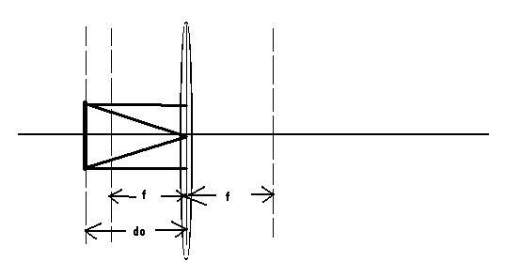
5. The figure below shows the rays on the left-hand-side of the lens. Continue the rays on the right-hand-side.
6. A lens is used to collect the full width at half power beam divergence (perpendicular to the junction) of 40° from a semiconductor laser into the 10° acceptance angle of an optical fiber.
i) is the image of the near field aperture of the semiconductor laser magnified or reduced at the input plane of the fiber?

ii) what is the ratio of magnification or reduction?

7. A light ray proceeds from air (n1 = 1) into Si (n2 = 3.4). If the incident angle is θi = 10o, what is the transmission angle θt ?

8. For a critical angle to exist between two media with index n1 and n2,
a) the light ray must be traveling from a low index to a high index,
b) the index difference must greater than tan-1(n2/(n1 + n2)),
c) the loss in the high index medium cannot exceed the loss in the low index medium, and/or
d) the light ray must be traveling from a high index to a low index.
9. In the figure below, light is incident from Region 1 with n1 = 3.4, into Region 2 with n2 = 1.

i) Find the fraction of light reflected back into Region 1.

ii) Find the fraction of light transmitted into Region 2.

10. Consider two pulses propagating in pure silica. The spectral bandwidth of one pulse is centered at a free space wavelength of λ = 1.35 µm and the spectral bandwidth of the second pulse is centered at a free space wavelength of λ = 1.40 µm. Which pulse will travel faster in the silica? (You may want to refer to Fig. 3-8 (from your text) below.)

11. Find the amount of pulse spreading in pure silica for a laser operating at a free space wavelength of 1.5 μm. The laser has a spectral emission width of 2 nm. The length of the silica is 3000 km. (You may want to refer to Fig. 3-8 below.)
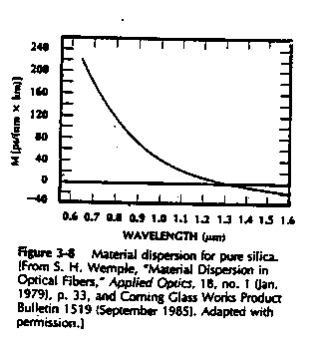

12. The normal human voice can be reproduced quite well with a bandwidth of 4 kHz. Why do some telephone companies allocate 64 kbps for a single voice channel?

13. What is the maximum number of phone calls (voice channels) that a fiber can carry at a data rate of 1 Gbps (109 bps)? Assume that each voice channel requires 64 kbps.

14. The near-field spot size (or optical output aperture) of a semiconductor laser is 2 µm perpendicular to the junction and 4 µm parallel to the junction. The free space wavelength of the semiconductor laser is 1.3 µm. Estimate the far-field beam divergence i) perpendicular and ii) parallel to the junction of the laser.

15. How is a soliton different from conventional optical pulses that propagate on optical fibers?
a) Only one soliton pulse can be in a fiber at a time.
b) A soliton pulse does not spread.
c) A soliton pulse travels at the same speed as a conventional pulse but contains more information.
d) A soliton pulse travels faster than a conventional pulse but contains less information.
16. A Gaussian light beam is focused to a spot by a lens. The diameter (2w) of the input beam is 4 mm. What is the spot size wo of the focused spot if the wavelength of the beam is 1.5 µm and the focal length of the lens is 5 cm?

17. The numerical aperture of an optical receiver (in air) is 0.2. What is the maximum acceptance angle for incident light rays?

18. The principle of least time can be used to derive
a) Snell's law,
b) the law of refraction,
c) the law of reflection,
d) the thin lens equation, and/or
e) the best path for a lifeguard to rescue a drowning person
19. How far does light with a wavelength of 0.8 µm travel in one picosecond (10-12 sec)?

20. The velocity with which information propagates on an electromagnetic carrier is given by
a) the group velocity dω/dk for analog signals and the phase velocity ω/k for digital signals
b) the phase velocity ω/k
c) the group velocity dω/dk for digital signals and the phase velocity ω/k for analog signals
d) the group velocity dω/dk
CERTIFICATION OF TESTING ENVIRONMENT:
I certify that I have completed this test in the 80 minute time period allotted, and that I have neither given nor received help from another person, nor have I had advanced access to questions or answers.
Signed:________________________________
OFF-CAMPUS STUDENTS ONLY:
I distributed and collected these test materials in an 80 minute interval
on_______________________________(date).
Signed__________________________________
Site Coordinator must sign to be counted

