ELECTRICAL ENGINEERING DEPARTMENT
SOUTHERN METHODIST UNIVERSITY
FIBER OPTIC TELECOMMUNICATIONS

SMU EE 5378 NTU-TM-513-N FINAL MAY 10, 1994

Please read the following before beginning:

- Each question is worth 3 points (unless otherwise stated).
- Some of the multiple choice questions may have more than one correct answer listed. If so, circle all of the correct responses for the question.
- Please print your name at the bottom of the remaining pages.
- The last three pages of this exam contain supplementary figures and information that may be useful in solving some of the problems below.

- i) Consider two semiconductor lasers, both with an output of 1 mW. The emission wavelength of one laser is 1.3 μm and that of the other is 1.55 μm. Which source emits the most photons/sec?

- How many photons/second is each source emitting in part i)?

- When an electromagnetic wave propagates from one medium with an index of refraction of n₁ into a second medium with an index of refraction of n₂,

- only the frequency changes,
- only the wavelength changes,
- both the frequency and the wavelength change, and/or
- the frequency and the wavelength both remain the same.

- A lens is used to collect the full width at half power beam divergence (perpendicular to the junction) of 50° from a semiconductor laser into a fiber that can accept light rays within a cone having a 5° half angle.

- Is the image of the near field aperture of the semiconductor laser magnified or reduced at the input plane of the fiber?
- What is the ratio of magnification or reduction?

- For a critical angle to exist between two media with index n₁ and n₂,

- the light ray must be traveling from a low index to a high index,
- the index difference must be greater than cotan⁻¹(n₂/(n₁ + n₂)),
- the loss in the high index medium cannot exceed the loss in the low index medium, and/or
- the light ray must be traveling from a high index to a low index.

- In the figure below, light is incident from Region 1 with n₁=1.0 into Region 2 with n₂ = 1.45.
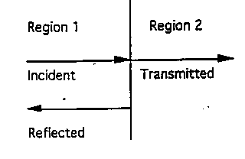

- Find the fraction of light reflected back into Region 1.

- Find the fraction of light transmitted into Region 2.

- Find the amount of pulse spreading in pure silica for a dfb laser operating at a free space wavelength of 1.55 μm. The dfb laser has a spectral emission width of 0.01 nm. The length of the silica is 100 km. (You may want to refer to Fig. 3-8 o the supplementary pages at the end of this exam.)

- What is the maximum number of video channels that a fiber can carry at a data rate of 2 Gbps (2 x 10⁹ bps)? Assume that each video channel requires 6 Mbps.

- The near-field spot size (or optical output aperture) of a semiconductor laser is 1.5 μm perpendicular to the junction and 3 μm parallel to the junction. The free space wavelength of the semiconductor laser is 1.55 μm. Estimate the far-field beam divergence i) perpendicular and ii) parallel to the junction of the laser.

- How is a soliton different from conventional optical pulses that propagate on optical fibers>

- Only on soliton pulse can be in fiber at a time.
- A soliton pulse does not spread.
- A soliton pulse travels at the same speed as a conventional pulse but contains more information.
- A soliton pulse travels faster than a conventional pulse but contains less information.

- The principle of least time can be used to derive

- Snell's law
- the law of refraction
- the law of reflection
- the thin lens equation
- the best path for a lifeguard to rescue a drowning person, and/or
- the optimum index profile of a GRIN fiber to minimize modal distortion

- How far does light with a wavelength of 1.55 μm travel in one picosecond (10⁻¹² sec) in an optical fiber if the effective index is 1.47?

- The velocity with which information propagates on an electromagnetic carrier is given by

- the group velocity dω/dk for analog signals and the phase velocity ω/k for digital signals
- the phase velocity ω/k
- the group velocity dω/dk for digital signals and the phase velocity ω/k for analog signals
- the group velocity dω/dk

- Give the formula for the numerical aperture (NA) of an optical fiber and define all of the symbols:

- Calculate the numerical aperture of a step index fiber with a core index of 1.47, a cladding index of 1.465, a core radius of 4 μm, and a cladding radius of 100 μm. The indices of refraction are specified at λ = 1.55 μm.

- Consider an LED with a quantum efficiency of 50%, emitting at a wavelength of 0.83 μm. Sketch the light (optical output power) versus drive current for this device.

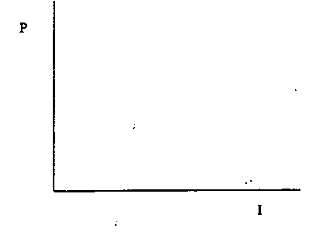
(hint: one applicable formula is P = ηIE_{g} . If you use this formula, explain each symbol and give the units for each symbol.)

- i) For the LED described in problem 15, how much optical power is emitted at a drive current 25 mA?

ii)what does the acronym "LED" stand for?

- A laser diode has a threshold current of 20 mA and a slope efficiency of 0.5 mW/mA. Sketch the light (optical output power) versus drive current for this device.

- i) For the laser described in problem 17, how much optical power is emitted at a drive current of 60 mA?

ii) what does the acronym "laser" stand for?

- NOTE: this problem (#19) is worth only one (1) point:

i) What does the acronym "SONET" stand for?

ii) What do you suppose Robert Black thinks "SONET" stands for?

20. Sketch the ray trajectories inside a GRIN fiber. The open box below represents the core of the GRIN fiber and region outside the core represents the cladding region.

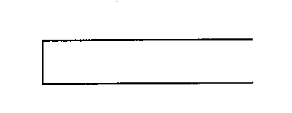

21. Which of the following detectors would be the best choice for a single mode optical fiber communication system if the optical source is a dfb laser with an emission wavelength of λ = 1.55 μm? Explain your choice.

a) a silicon PIN photodiode
b) a silicon APD photodiode
c) an indium gallium arsenide PIN photodiode

22. i) what does the acronym "PIN" stand for?
ii) what does the acronym "APD" stand for?
iii) convert 50 μW to dBm

23. A Si PIN photodiode has a responsivity of 0.5 A/W. If 80 μW are incident on the detector, what current flows through the load resistor?

24. A 1.3 μm surface-emitting LED emits light to be captured by a dielectric slab waveguide. Circle the figure most likely to represent the true case.

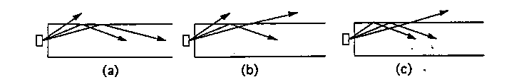

25. For the fundamental mode, which of the following waveguides have (or has) a cutoff wavelength (for a finite slab or core thickness)?

a) a symmetric slab waveguide
b) a step-index circular optical fiber waveguide
c) an asymmetric slab waveguide

26. Consider a symmetric slab waveguide with n1 = 3.6 and n2 = 3.55. (You may want to refer to the Fig. 4-5 on the supplementary pages at the end of this exam.)

i) If the thickness of the slab 1.75 μm, how many modes will propagate if radiation from an LED with a free space wavelength of 0.83 μm is coupled into the slab waveguide?

ii) For what range of wavelengths will the waveguide in part i) only support one mode?

27. Approximately how many modes will an optical fiber with a core diameter of 100 μm and a cladding diameter of 250 μm support if the core index is 1.5 and the clad index is 1.48? Asssume that the radiation propagating in the fiber has a free space wavelength of 0.98 μm.

28. i) How is the lowest order mode in a step index fiber designated (TE₀₀, HE₁₁, EH₀₀ ...)?

ii) For a single mode fiber, the V parameter is typically chosen to be between 2 and 2.4. Why?

29. i) If n1 = 1.47 and n2 = 1.465, what diameter should we choose for the fiber core if we want the V parameter to be 2.2 for radiation propagating from a 1.55 μm dfb laser with a linewidth of 0.1nm?

ii) the fiber in i) is also used to provide pump radiation from a semiconductor laser to an erbium doped fiber amplifier. The pump wavelength is 0.98 μm. Is the fiber single-mode at the pump wavelength?

30. Consider a step-index single mode fiber communication system operating at a free space wavelength of λ = 1.6 μm. Does material dispersion or waveguide dispersion contribute the most to the total dispersion? Base your explanation on Figs. 3-8 and 5-23.

31. The dark current in an InGaAs PIN photodiode is 15 nA (15 x 10-9 A). If the responsivity is 0.6 A/W, estimate the minimum detectable power.

32. i) If you want an optical source that you can modulate at the highest speeds, would you choose a laser or an LED?

ii) If you want an optical source with the narrowest linewidth, would you choose a dfb laser, a conventional laser, or an LED?

iii) If you want the best coupling efficiency and the highest power into an optical fiber, would you choose a laser or an LED?

iv) If you want the best reliability, would you choose a laser or an LED?

33. The effective index of the fundamental mode of an InGaAsP dfb semiconductor laser emitting at 1.6 μm is 3.44. Calculate the first-order grating period for this device.

34. A communication channel consists of a 1.55 μm dfb laser, a step-index single mode fiber, and an InGaAs PIN photodiode detector. The fiber loss is 40 dB. The minimum detectable power at the detector is 30 nW. What is the minimum power required from the laser? Assume the coupling efficiency of the laser to the fiber is 50% and that 100% of the light from the fiber is coupled to the detector.

