ELECTRICAL ENGINEERING DEPARTMENT
SOUTHERN METHODIST UNIVERSITY
FIBER OPTIC TELECOMMUNICATIONS

SMU EE 5303 NTU TM-513-N Final May 11, 1996

Name (print): ________________________
Student ID #: ________________________
Exam date: _________ Time: ________
Exam Location: ________________________

TIME: The allowed time period is three hours.

CONSTRAINTS: This exam is closed to books and notes with the exception below.

ALLOWED: 3 pages of notes (81/2 x 11; can write on both sides); calculators; straight edge; ruler; compass.

Read the following notes before starting the exam:

Note #1: the first 33 questions are worth 3 points and worth 1 point.

Note #2: Some of the multiple choice questions may have more than one correct answer listed. If so, circle all of the correct responses for the question.

Note #3: Please print your name at the bottom of the remaining pages.

Note #4: Please indicate your location: NTU, TAGER, Video, Video on Campus, or Campus-live

Note #5: please provide a brief explanation of your answers to multiple-choice type questions.

1. Give a brief explanation of material dispersion.

2. Give a brief explanation of waveguide dispersion.

3. Give a brief explanation of modal distortion.

4. If the index of refraction of a material is independent of wavelength (the index has the same value at all wavelengths), would

a) material dispersion exist? briefly explain

b) waveguide dispersion exist? briefly explain

c) modal distortion exist? briefly explain

5. When an electromagnetic wave propagates from one medium with an index of refraction of n1 = 1.5 into a second medium with an index of refraction of n2 = 1.0,
a) only the frequency changes,
b) only the wavelength changes,
c) both the frequency and the wavelength change, and/or
d) the frequency and the wavelength both remain the same.
Briefly explain your answer:

6. If 1 mW of optical power at a wavelength of 1.3 µm is launched into a fiber with an optical loss of 0.1 dB/km, how far can the signal propagate in the fiber before the signal power is reduced to 1 nW (10-9 W)?

7. In the figure below, light is incident from Region 1 with n1 = 1.0, into Region 2 with n2 = 1.5.

i) Find the fraction of light reflected back into Region 1.

ii) Find the fraction of light transmitted into Region 2.
8. i) the index that describes the propagation of a pulse or an optical signal that contains information is
a) the group index ng = c/(dω/dk)
b) the material index n = c/(ω/k)

ii) the index that describes the propagation of a plane wave or a ray is
a) the group index ng = c/(dω/dk)
b) the material index n = c/(ω/k)

Briefly explain your answers.

9. The velocity with which information propagates on an electromagnetic carrier is given by
a) the group velocity dω/dk for analog signals and the phase velocity ω/k for digital signals
b) the phase velocity ω/k
c) the group velocity dω/dk for digital signals and the phase velocity ω/k for analog signals
d) the group velocity dω/dk

Briefly explain your answer:

10. i) A light ray proceeds from glass (n1 = 1.5) into AlGaAs (n2 = 3.4). If the incident angle is θi = 10°, what is the transmission angle θt ?

ii) For a critical angle to exist between two media with index n1 and n2,
a) the light ray must be traveling from a low index to a high index,
b) the index difference must greater than tan-1(n2/(n1 + n2)),
c) the loss in the high index medium cannot exceed the loss in the low index medium, and/or
d) the light ray must be traveling from a high index to a low index.

Briefly explain your answer:

11. A semiconductor laser emits optical radiation with a free space wavelength of 0.98 µm. What is the i) frequency, ii) velocity, and iii) wavelength of the optical radiation inside the semiconductor laser? Assume that the index of refraction of the semiconductor laser material is 3.4.

12. i) The normal human voice can be reproduced quite well with a bandwidth of 4 kHz. Why do telephone companies commonly use 64 kbps for a single voice channel?

ii) What is the maximum number of phone calls (voice channels) that an optical fiber communications link can carry at a data rate of 560 Mbps? Assume that each voice channel requires 64 kbps.

13. The near-field spot size (or optical output aperture) of a semiconductor laser is 1.5 µm perpendicular to the junction and 2.0 µm parallel to the junction. The free space wavelength of the semiconductor laser is 1.3 µm. Estimate the far-field beam divergence i) perpendicular and ii) parallel to the junction of the laser.

14. A collimated Gaussian light beam is focused to a spot by a lens. The diameter (2w) of the collimated beam is 2.0 mm. What is the diameter of the spot size (2wo) of the focused spot if the wavelength of the beam is 1.55 µm and the focal length of the lens is 3 mm?
15. i) The numerical aperture of an optical receiver (in air) is 0.4. What is the maximum acceptance angle for incident light rays?

ii) The maximum acceptance angle (half of the acceptance cone full angle) for an optical fiber is 9°. What is the numerical aperture of the fiber?

Briefly explain your answer.

16. How long does it take light to travel one foot in free space?

For problems 17 through 19 consider the five curves (attached at the end) that correspond to quenched SiO2 (Case A) that were plotted from equations in the Electronics Letters paper.

17. At what wavelength will a pulse propagating in this material have zero dispersion? Indicate the wavelength on the appropriate graph and give a numerical value for the wavelength.

18. i) As the wavelength of the pulse moves away from (increases or decreases) the zero dispersion wavelength, what happens to the velocity of the pulse? (does it increase or decrease or what?)

ii) Give a physical explanation for your answer in part i).

19. i) Now consider a ray (or an unmodulated plane wave) propagating in the same material. As the wavelength of the ray moves away from the zero dispersion wavelength (increases or decreases), what happens to the velocity of the pulse? (does it increase or decrease or what?)

ii) Give a physical explanation for your answer in part i).

20. Find the amount of pulse spreading in a single mode fiber if the optical source is a dfb laser operating at a free space wavelength of 1.56 µm. The laser has a spectral emission width of 0.1 nm. The length of the silica fiber is 3000 km. (You may want to refer to one or more of the attached dispersion curves to estimate the dispersion.) Indicate the contributions to pulse spreading from a) material dispersion, b) waveguide dispersion, and c) multimode distortion.

21. What is the maximum data rate allowed for the communication link described in problem 20? Assume a non-return to zero (NRZ) digital signal.

22. A SI fiber has core refractive index of n1 = 1.450, and a cladding index of
n2 = 1.445. The normalized frequency is 2.2 If the source wavelength is
λ = 1.5 µm:
a) what is the core radius of this fiber?
b) what is the numerical aperture (NA) of this fiber?
c) what is the spot-size of this fiber?
d) how many modes can propagate in this fiber? Briefly explain your answer.

23. i) Sketch the refractive index profile of a step-index (SI) fiber:
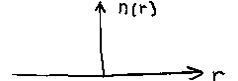
ii) Sketch the ray trajectories inside a step-index fiber. The open box below represents the core of the step-index fiber and the region outside the core represents the cladding region.

iii) Sketch the refractive index profile of a graded-index (GRIN) fiber:

.
iv) Sketch the ray trajectories inside a GRIN fiber. The open box below represents the core of the GRIN fiber and the region outside the core represents the cladding region.

24. For a symmetric slab waveguide with index n2= 3.55 and n1 = 3.6, how many modes will propagate if the waveguide thickness is 3.0 µm and the free space wavelength of the light propagating in the waveguide is 1.55 µm? Include both TE and TM polarizations.

25. Consider either a symmetric slab waveguide or a circular step index fiber. If the geometry, wavelength, and cladding index remains constant, but the index of the core increases,

i) will the effective index increase or decrease? Briefly explain.

ii) will the number of modes increase or decrease? Briefly explain.

26. An ideal laser diode has a threshold current of 15 mA and a slope efficiency of 0.3 mW/mA.

i) Sketch the light (optical output power) versus drive current for this device for a current range of 0 to 100 mA.

ii) How much optical power is emitted at a drive current of 50 mA?

27. Which of the following waveguides have (or has) a cutoff wavelength (for a finite, non-zero slab or core thickness) for the lowest-order mode? Briefly explain your choice(s).
a) a symmetric slab waveguide
b) a step-index circular optical fiber waveguide
c) an asymmetric slab waveguide
28. Approximately how many modes will a step index optical fiber with a core diameter of 75 µm and a cladding diameter of 150 µm support if the core index is 1.47 and the cladding index is 1.46? Assume that the radiation propagating in the fiber has a free space wavelength of 1.55 µm.

29. For a single mode fiber, the V parameter is typically chosen to be between 2 and 2.4.

i) Why is the lower limit typically about 2?

ii) Why is the upper limit about 2.4?

30. Consider a step-index single mode fiber communication system operating at a free space wavelength of λ = 1.6 µm. Does material dispersion or waveguide dispersion contribute the most to the total dispersion? Base your explanation on Figs. 3-8 and 5-23.

31. i) Identify the following TM modes of a symmetric slab waveguide:
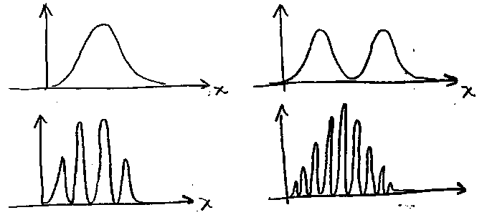

ii) are the distributions shown above field distributions or intensity distributions? Briefly explain.

32. You have to use an LED as a source for a fiber system. You can choose between single-mode SI, single-mode GRIN, multi-mode SI, and multi-mode GRIN fibers. What is the best choice (assuming that the core diameters and the Δns are the same for the single-mode fibers, and the core diameters and the Δns of the multi-mode fibers are the same)? Briefly explain your choice.

33. You are using a DFB laser as a source for a fiber system. You can choose between single-mode SI, single-mode GRIN, multi-mode SI, and multi-mode GRIN fibers. What is the best choice (assuming that the core diameters and the Δns are the same for the single-mode fibers, and the core diameters and the Δns of the multi-mode fibers are the same)? Briefly explain your choice.

This final problem is worth only 1 point:
34. The principle of least time can be used to derive
a) Snell's law,
b) the law of refraction,
c) the law of reflection,
d) the thin lens equation,
e) the optimum graded index profile to minimize multimode distortion in a GRIN fiber,
e) the best path for a lifeguard to rescue a drowning person

CERTIFICATION OF TESTING ENVIRONMENT:
I certify that I have completed this test in the 3 hour time period allotted, and that I have neither given nor received help from another person, nor have I had advanced access to questions or answers.

Signed:________________________________

OFF-CAMPUS STUDENTS ONLY:
I distributed and collected these test materials in a three hour time interval
on_______________________________(date).

Signed__________________________________
Site Coordinator must sign

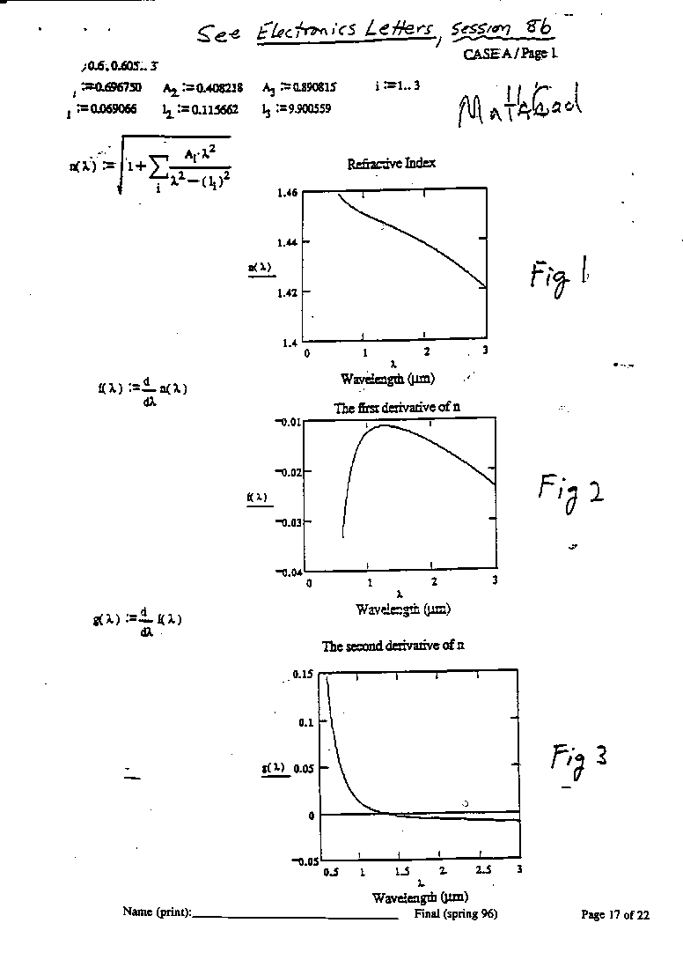

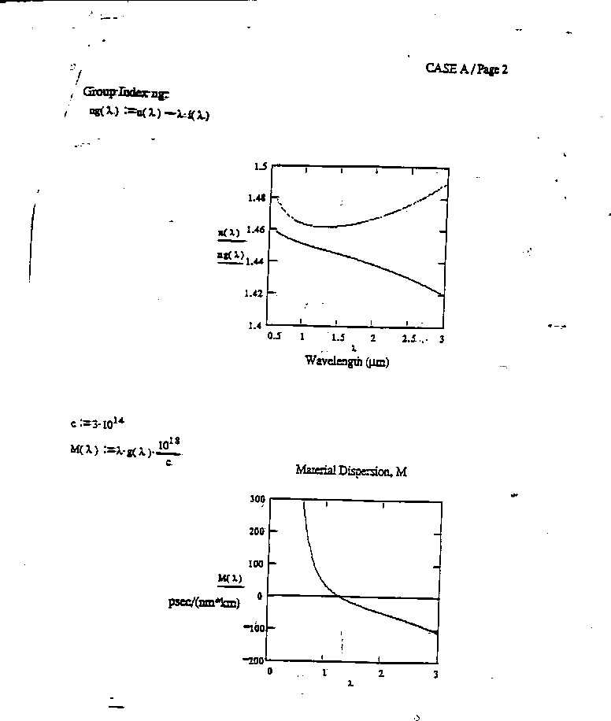

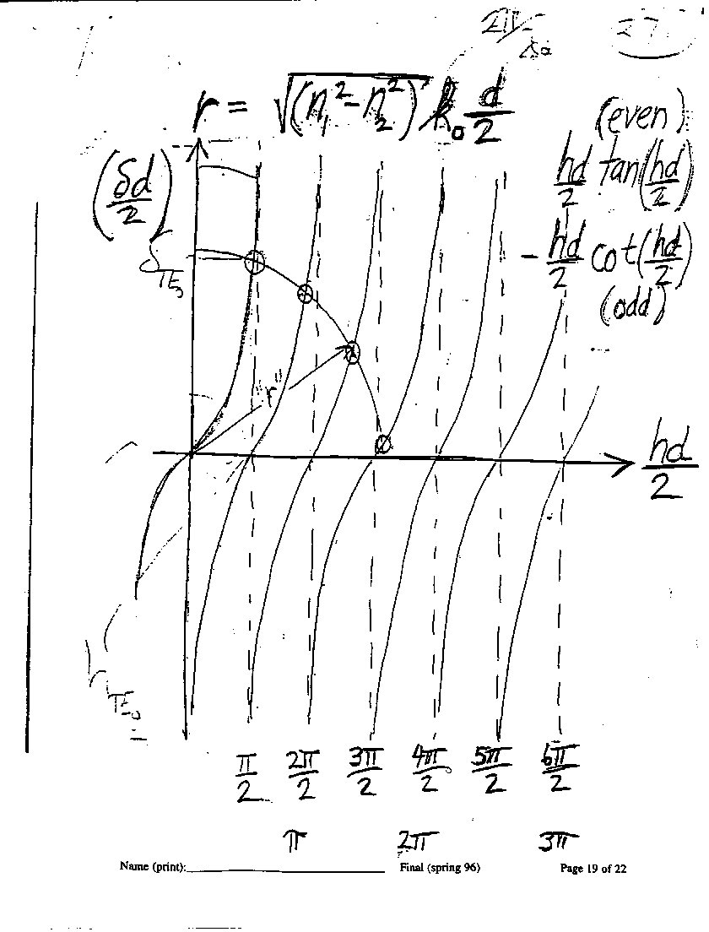

g

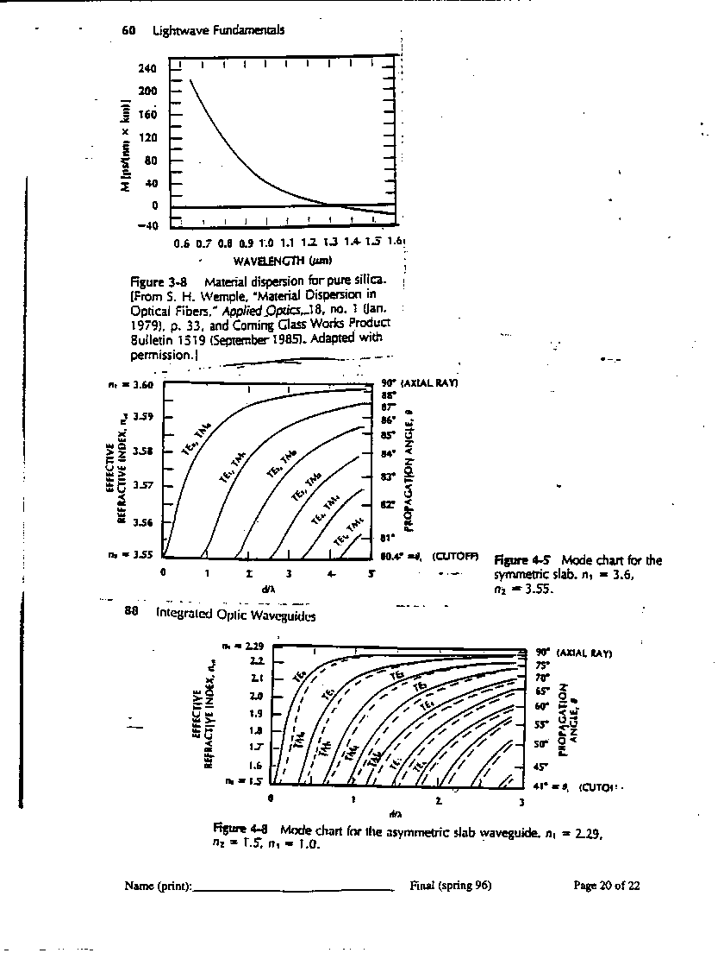
g

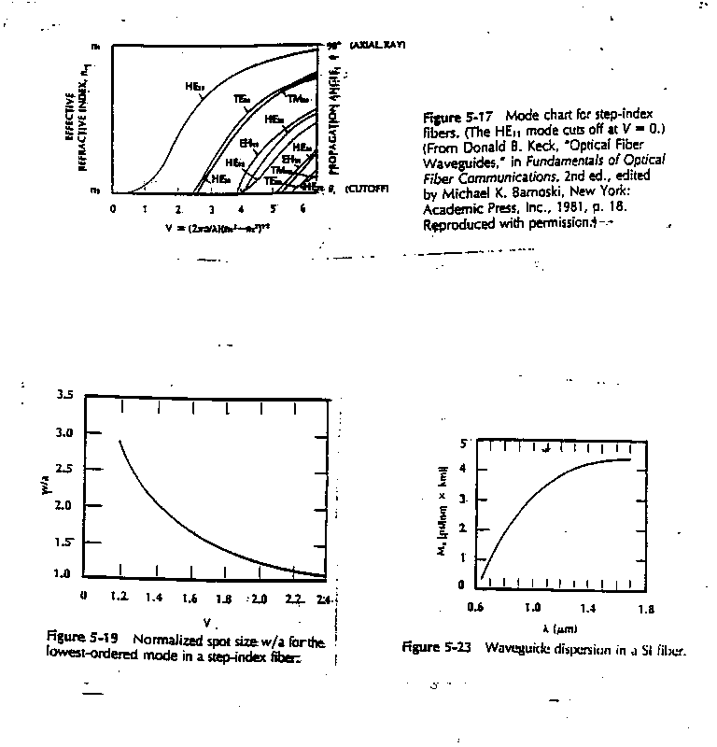
g

